Problem 1: check the number of occurrence of a string

Program code

#include<iostream>

#include <string>

using namespace std;

void count(const char s[], int counts[]);

int main()

{

     char s[80];

     int counts[26];

     gets(s);

     count(s, counts);

     return 0;

}

void count(const char s[], int counts[])

{

     int i,j;bool check;

     for(i=0;i<=25;i++)

         {

              counts[i]=0;

         } // 把counts都变成0

     char character[26];

     for (i=0;i<=25;i++)

         {

              character[i]='A'+i;

         }

     int ascll[26];

     for(i=65;i<=90;i++)

         {

              ascll[i-65]=(i-65);

         }//把ascll 以此变成0,1,2，....25

     for(i=0;i<=80;i++)

         {

              check=false;

              for (j=0;j<=25;j++)

                   {

                       if ((s[i]-'A')==j || (s[i]-'A')==(j+32))

                            check=true;

                   }

              if (check==false)

                   break;

              for (j=0;j<=25;j++)

                   {

                       if ((s[i]-'A')==j || (s[i]-'A')==(j+32))

                            counts[j]++;

                       //得出[s]的ascll码，然后做比较

                   }

         }

     int k;

     k=0;

     for(i=0;i<=25;i++)

         {

              cout<<counts[i]<<"   ";//如果那个个数不为0，输出那个个数

              k++;

              if(k%10==0)

                   cout<<endl;

         }

     cout<<endl;

}

Program analysis

1. using ASCLL code to check which  character the char array refer to .
2. create several array to store the sequential letter
3. using two loop statement to count the number of occurrence.

Program result

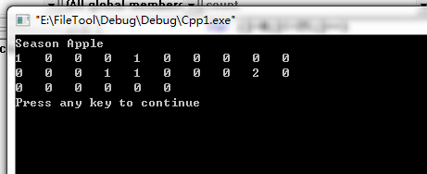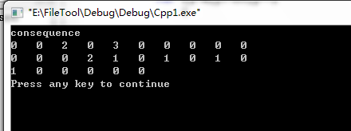

Problem 2: find the maximum and minimum of an array of int, and find the localtion

Program code

#include<iostream>

using namespace std;

int main()

{

     int s[8];

     for (int i=0;i<=7;i++)

         {

              cin>>s[i];

         }

     int m,loacl1;

     m=0;

     for (i=0;i<=7;i++)

         {

              if(s[i]>m)

                   m=s[i];

         }

     for ( i=0;i<=7;i++)

         {

              if(s[i]==m)

                   {

                   loacl1=i;

                   break;

                   }

         }

     int n,loacl2;

     n=s[1];;

     for (i=0;i<=7;i++)

         {

              if(s[i]<n)

                   n=s[i];

         }

     for ( i=0;i<=7;i++)

         {

              if(s[i]==n)

                   {

                   loacl2=i;

                   break;

                   }

         }

     cout<<"The maximun is "<<m<<" and the loacaltion of the maximum is "<<loacl1+1<<endl;

     cout<<"The minimun is "<<n<<" and the loacaltion of the minimum is "<<loacl2+1<<endl;

     return 0;

}

Program analysis

Using two loop statement to find the result

Program result

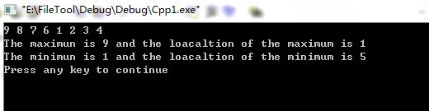

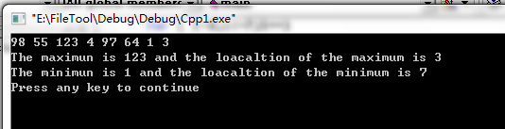

Problem 3:

Find the initial of a n\*n matrix

Program code

#include<iostream>

#include <string>

using namespace std;

int main()

{

int n,c;

c=1;int i,j;

cin>>n;

int sum=1;

for( i=1;i<=n;i++)

{

for (j=1;j<=i;j++)

{

cout<<sum<<" ";

sum++;

}

for (j=i+1;j<=n;j++)

{

cout<<"0"<<" ";

}

cout<<endl;

} // A型矩阵

int a[50][50];

sum=1;

for (i=0;i<=n-1;i++)

{

for(j=0;j<=n-i-2;j++)

{

a[i][j]=0;

}

for(j=n-i-1;j<=n-1;j++)

{

a[i][j]=sum;

sum++;

}

}

for (i=0;i<=n-1;i++)

{

for(j=0;j<=n-1;j++)

cout<<a[j][i]<<" ";

cout<<endl;

}

return 0;

}}

Program analysis

Using two similar double loop the output the number

Program result